The Oculomotor System

Seqian Wang, in collaboration with Sulantha Mathotaarachchi and Maxime Parent

# Part 1

## 1a) Solving the linear differential equation during saccade

$$F=kθ+r\frac{dθ}{dt}$$

$$\frac{dθ}{dt}+\frac{k}{r}θ=\frac{F}{r}$$

$$e^{\int{\frac{k}{r}dt}}=e^{\frac{k}{r}t}$$

$$(\frac{dθ}{dt}+\frac{k}{r}θ)e^{\frac{k}{r}t}=\frac{F}{r}e^{\frac{k}{r}t}$$

$$θe^{\frac{k}{r}t}={\frac{F}{r}e}^{\frac{k}{r}t}×\frac{r}{k}+c$$

$$θ=\frac{F}{k}+c×e^{-\frac{k}{r}t}$$

To determine c, let t=0, θ=0:

$$0=\frac{F}{k}+c×e^{0}$$

$$C=-\frac{F}{k}$$

Thus,

$$θ=\frac{F}{k}(1-e^{-\frac{k}{r}t})$$

## 1b) Find F

$$F=\frac{k}{1-e^{-\frac{k}{r}t}}θ$$

Using Robinson’s constants ( $k=1.25\frac{g}{°}$, $r=0.22\frac{gs}{°}$):

### For 10° (45ms)

$$F=\frac{k}{1-e^{-\frac{k}{r}0.045}}10=55.40g$$

### For 20° (68ms)

$$F=\frac{k}{1-e^{-\frac{k}{r}0.068}}20=78.01g$$

### For 40° (110ms)

$$F=\frac{k}{1-e^{-\frac{k}{r}0.11}}40=107.59g$$

## 1c) Solve for the period after saccade

Since the eye is immobile, $\frac{dθ}{dt}=0$. As such, $F=kθ$ and $θ=\frac{F}{k}$.

## 1d) Plot pulse-steps

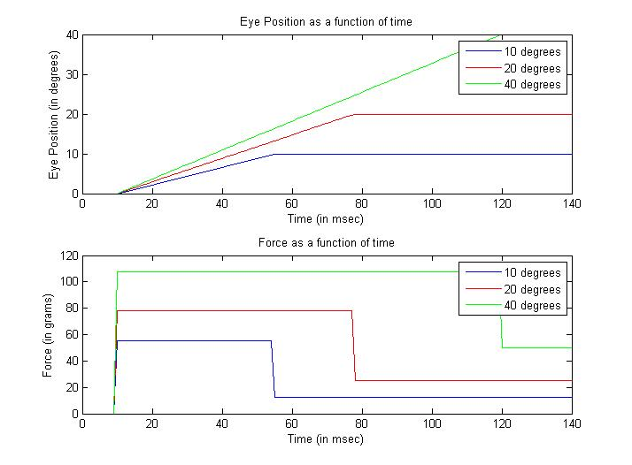

Figure : Eye Position and Force as a function of time. Saccades with increasing amplitudes require pulses that are stronger (force) and that last longer (time). They also require a higher force after the saccade to immobilize and maintain the eye at its position.

# Part 2

## 2a) Plant Diagram

Equation 2 from the previous exercise is a first order representation of the plant. It can be organized as such:

$$F=kθ+r\frac{dθ}{dt}$$

$$θ=\frac{F-r\frac{dθ}{dt}}{k}=\frac{1}{k}(F-r\frac{dθ}{dt})$$

Likewise, the plant can be represented as such:

$$θ_{out}=A(F-B\frac{dθ}{dt})$$

Thus, $A=\frac{1}{k}$ and $B=r$.

This makes sense. It suggests that the force from the burst generator is subject to spring resistance k and some viscous resistance r as a function of change rate ($\frac{dθ}{dt}$).

## 2b) Box 1 and 3

### Box 1 Equation

$$ff=BG(r+k\int{dt})$$

### Box 3

Since $ff≡F$, Box1 $≡$ Box2

$$BG\left(r+k\int{dt}\right)=r\frac{dθ}{dt}+kθ$$

$$BG\int{dt}=θ$$

Thus, Box 3 contains $\int{dt}$. In other words, BG or the firing frequency, which is akin to velocity here, can be integrated over time to determine the eye position (in deg).

## 2c) Pulse-Step for a 40 degrees saccade

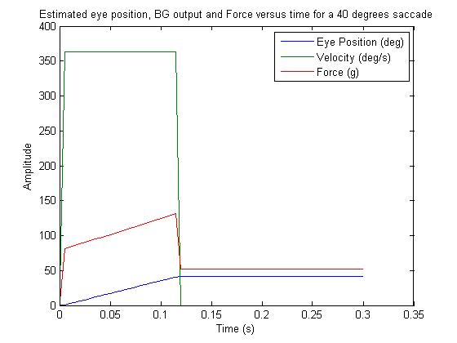

Figure 2: The Force Profile, Eye Position and Velocity for a 40 degrees saccade. The eye position gradually increases until it reaches 40°. The eye velocity is high during eye movement. The force increases over time during the saccade, then shoots to a lower force to keep the eye at its position following saccade.

## 2d) Plant Equation 2 Solution

For different values of t and y, we first interpolate the force profile using interp1, then use ode45 to solve the differential equation.

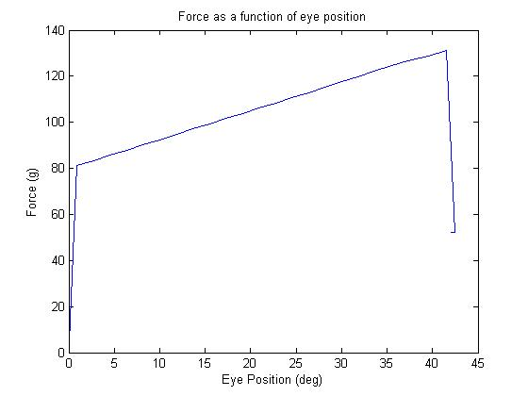

Figure : Force profile as a function of eye position. The force increases as it is pulling the eye, but decreases once it reaches the desired saccade.

## 2e) Eye Position vs Time

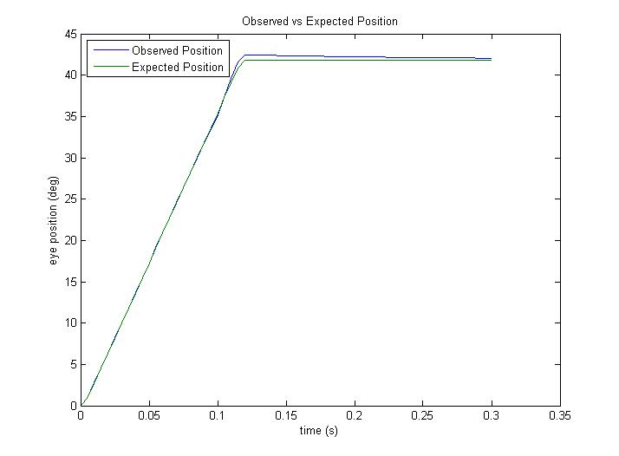

Figure : Observed vs Expected Eye Position. The Expected Eye Position is the Desired Eye Position from our Burst Generator. The Observed Eye Position is the Actual Eye Position as a function of a force and the eye properties. The shocking similarity between the two models suggests that Box 1 and Box 2 are almost identical, thus ff from the burst generator = force on the eye.

## 2f) Deficient Integrator Output, Resultant Eye Trajectory

Simply dividing the k constant by 2 to calculate the loop output force temporal profile should do the trick (but keeping the original k when using the plant equation).

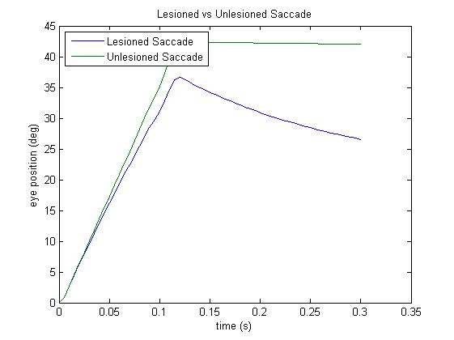

Figure : Eye Position for a 40 degrees saccade in a normal vs deficient integrator output. The lesioned integrator fails to produce the proper firing frequency to attain the desired eye saccade. As a result, the eye is incapable of reaching 40 degrees. Worse, the force following the saccade is insufficient to maintain the eye immobile, and the eye leans towards the midline (0 degrees).